NOTICE OF RACE
44th Singapore Open Windsurfing, Wing & Wind Foiling Championship

Date:
13th to 16th February 2025

Venue:
For Windsurfing & Wing Foiling : Constant Wind Sea Sports,
11 Changi Coast Walk, Singapore 499740

For Wind Foiling: Aloha Sea Spots Centre,
1212 East Coast Parkway, Singapore 449886

Organising Authority:
Windsurfing Association Singapore
Supported by: Singapore Sailing Federation
Sponsor: Aloha Sea Sports Centre
Co-Sponsor: Constant Wind Sea Sports Centre

- RULES
  - The event will be governed by the rules as deﬁned in 2021 - 2024 RACING RULES OF SAILING (Windsurfing Fleet Racing Edition) and The Class Rules of participating classes such as:
    - The T293 & TPlus Class Rules
    - The International Windsurfer (LT) Class Rule
    - International IQ Foil Class Rules and related Wind Foil Rules
    - International Wing Foil Class Rules

  - No National Authority prescriptions will apply.
  - If there is conﬂict between the Class Rules and the Notice of Race, the Notice of Race will take precedence.
  - If there is conﬂict between the Notice of Race and the Sailing Instructions (SI’s), the SI will take precedence.
  - If there is a conﬂict between languages, the English text will take precedence.

ADVERTISING
[NP] Boards and sails may be required to display advertising chosen and supplied by the organizing authority.

CLASSES AND DIVISIONS
  - The participating classes and divisions shall be:
From 13/2/2025 to 16/2/2025:
    - Techno 293 (T293) – Junior Boy & Girl; Youth Boy & Girl
    - Techno 293 Plus (TPlus) – Open
    - IQ Foil U 17 – U17 Boy & Girl
    - IQ Foil U 19 - U19 Boy & Girl
    - IQ Foil Open - Men & Women
From 15/2/2025 to 16/2/2025:
    - Wind Foil - Open
    - Wing Foil - Men, Women, Masters, Grand Masters
    - RS:One - Open
    - Windsurfer LT - Grand Master, Master, Man, Women

  - The Age Divisions shall be:
    - A T293 Junior shall be under 15 years of age (born in or after 2011 but not later than 2013)
    - A T293 Youth, IQ Foil U17 shall be under 17 years of age (born in or after 2009)
    - IQ Foil U19 competitor shall be under 19 years of age (born in or after 2007).
    - A Master shall be between 40 -59 years of age in the year of competition (born between 1985 and 1966).
    - A Grand Master shall be 60 years of age or older, in the year of competition (born 1965 or earlier)
    - A minimum of 3 competitors is required to form a class.
- Within a class, a minimum of 3 competitors is required to form a division
- If there are insufficient competitors to form a division, all competitors will compete under a combined division within the class.
- The organizing committee reserves the overall right to decide the final formation of divisions and classes for this event.

ELIGIBILITY AND ENTRY

  - [NP] Competitors shall be members of a National Class Association which is a current paid-up member of the relevant international class association. Membership formalities can be completed on site.
  - Eligible competitors may register for the event by time 23:59, date 5th January 2025 (Sunday), to enjoy early bird registration discounts.
The following shall be presented upon registration:

Original Entry Form
  - Proof of age
  - Parental Permission Form- for competitors under the age of 18

FEES

  - The required entry fee for the following classes (4 days racing) are:
- S$180 for T293 Junior, IQ Foil U 17 and U19
- S$230 for T Plus & IQ Foil

For early bird registration (see 2.2) , the entry fees are as follows:
- S$120 for T293 Junior, IQ Foil U 17 and U19
- S$180 for T Plus & IQ Foil

  - The required entry fee for following classes (2 days racing) are as follows:
- S$130 for Wind Foil, Wing Foil, RS:One, Windsurfer LT

For early bird registration (see 2.2) the entry fees are as follows:
- For non-full time students: S$80 for Wind Foil, Wing Foil, RS:One, Windsurfer LT
- For full time students: S$50 for RS:One & Windsurfer LT

  - Entry fees may be paid in cash at registration or via bank transfer (see details below) with all bank charges to be borne by the participant.
Bank Account Name: Windsurfing Association Singapore

Bank Account No.: 065-002617-1 Bank Code: 7171
SWIFT Address: DBSSSGSG
Bank Name: DBS Bank Ltd

    - Entry fees paid at the registration counter shall be paid in cash in Singapore Dollars (S$).
    - Participants must produce evidence of fees paid via bank transfer by scanning a copy of the bank-in slip and sending it to max@alohaseasports.com.sg

RACE FORMAT
  - Each event in the Open Championship shall be a single discipline, course racing, “Open entry” event.
  - Men and women, boys and girls, may race together.
  - [NP] Classes may have separate starts.
  - [NP] The maximum number of races per day and the maximum number of races per series for each class shall be as follows:

Class | Max number of races / day | Max number of races per series | Remark
Techno 293 & 293 Plus | 4 | 15 | Race start from 13/2/2025 to 16/2/2025 (4 days)
IQ Foil – all divisions | 10 | 30
Wind & Wing Foil | 10 | 15 | Race start from 15/2/2025 to 16/2/2025 (2 days)
RS: One | 4 | 8
Windsurfer LT | 4 | 8

SCHEDULE
  - Schedule for Techno 293, 293 Plus & All IQ Foil divisions

Wed | 12th Feb | 1200 - 1600 | Registration & Equipment Inspection  Self-Practice
Thurs | 13th Feb | 1000 – 1030 | Skipper’s Brieﬁng
 |  | 1130 | First Possible start of racing
Fri | 14th Feb | 1100 | First possible start of racing
Sat | 15th Feb | 1100 | First possible start of racing
Sun | 16th Feb | 1100 | First possible start of racing
 |  | 1600 | Last possible warning signal
 |  | 1830 | Prize giving and Dinner
Note:
- Briefing and launching off location for Techno 293 & 293 Plus will be at Constant Wind, 11 Changi Coast Walk.
- Briefing and launching off location for all IQ Foil Divisions will be at Aloha Sea Sports, 1212 East Coast Parkway.
- You are advised to move all your equipment to the respective location prior to the start of the event
- Packed lunch will be provided for all competitors and officials from 13 ^{th} to 16th February 2025

  - Schedule for Wind & Wing Foil, RS:One and Windsurfer LT classes

Fri | 14th Feb | 1200 - 1600 | Registration and Equipment Inspection  Self Practice
Sat | 15th Feb | 1000 -1030 | Skipper’s Briefing
 |  | 1130 | First possible start of racing
Sun | 16th Feb | 1100 | First possible start of racing
 |  | 1600 | Last possible warning signal
 |  | 1830 | Prize giving and Dinner
Note:
- Briefing and launching off location for RS:One, Windsurfer LT and Wing Foil will be at Constant Wind, 11 Changi Coast Walk.
- Briefing and launching off location for Wind Foil will be at Aloha Sea Sports, 1212 East Coast Parkway.
- You are advised to move all your equipment to the respective location prior to the start of the event
- Packed lunch will be provided for all competitors and officials from 15th to 16th February 2025

SAILING INSTRUCTIONS

The sailing instructions (SI’s) will be available upon registration. Any changes to the SI’s shall be approved by the Organizing Committee and Class Representative

COURSES
Courses will be as described in the sailing instructions.

PROTEST COMMITTEE

An ‘Independent Protest Committee’ will be appointed.

SCORING
  - Scoring will be according to the WCR Appendix A, except as amended below for discards.
- When fewer than 4 races have been completed, a board’s series score shall be the total of her race scores.
- When 4 to 7 races have been completed, a board’s series score shall be the total of her race scores excluding her worst score.
- When 8 to 14 races have been completed, a board’s series score shall be the total of her race scores excluding her two worst scores.
- When 15 or more races have been completed, a board’s series score shall be the total of her race scores excluding her three worst scores.

SUPPORT BOATS

Support boats shall be registered at the race oﬃce.

SAFETY
13.1 Every competitors and support boat crew member shall wear a personal ﬂotation device that shall conform to the minimum standard of ISO 12402-5 (level 50), or as speciﬁed in the class rules.
13.2 All Foilers shall wear a helmet when racing at sea

PRIZES

14.1 Prizes will be awarded to the top three competitors of each properly constituted class /division.
14.2 Apart from the Open Division, winners of each division shall only be entitled to prizes within their respective division.

OFFICIAL CEREMONIES
Competitors are requested to attend the event’s social functions; however, the organising authority may refuse entry to those whose standard of attire is not commensurate with the occasion.

DISCLAIMER OF LIABILITY

Competitors participate in the event entirely at their own risk, see WCR 4 -Decision to Race. The organising authorities & supporting parties (WAS, Aloha, Constant Wind, SingaporeSailing) or any of their oﬃcials or representatives or the sponsors or their oﬃcials or representatives will not accept any liability for material damage or personal injury or death sustained in conjunction with or prior to, during or after the event.

INSURANCE

Each participating board shall be insured with valid third-party liability insurance.

RIGHT TO USE NAME AND LIKENESS

In registering for the event, competitors automatically grant to the Organising Authority the right in perpetuity to make, use and show from time to time at their discretion, any motion pictures, still pictures and live, taped or ﬁlmed television and other reproduction of them, taken during the period of the event, for the said Event as deﬁned in the Notice of Race and Sailing Instructions in which he/she participates without compensation.

REGISTRATION and OTHER INFORMATION

19.1 Registration can be done on-line at URL : https://tinyurl.com/44th-SG-OPEN-2025

Or scan QR code: 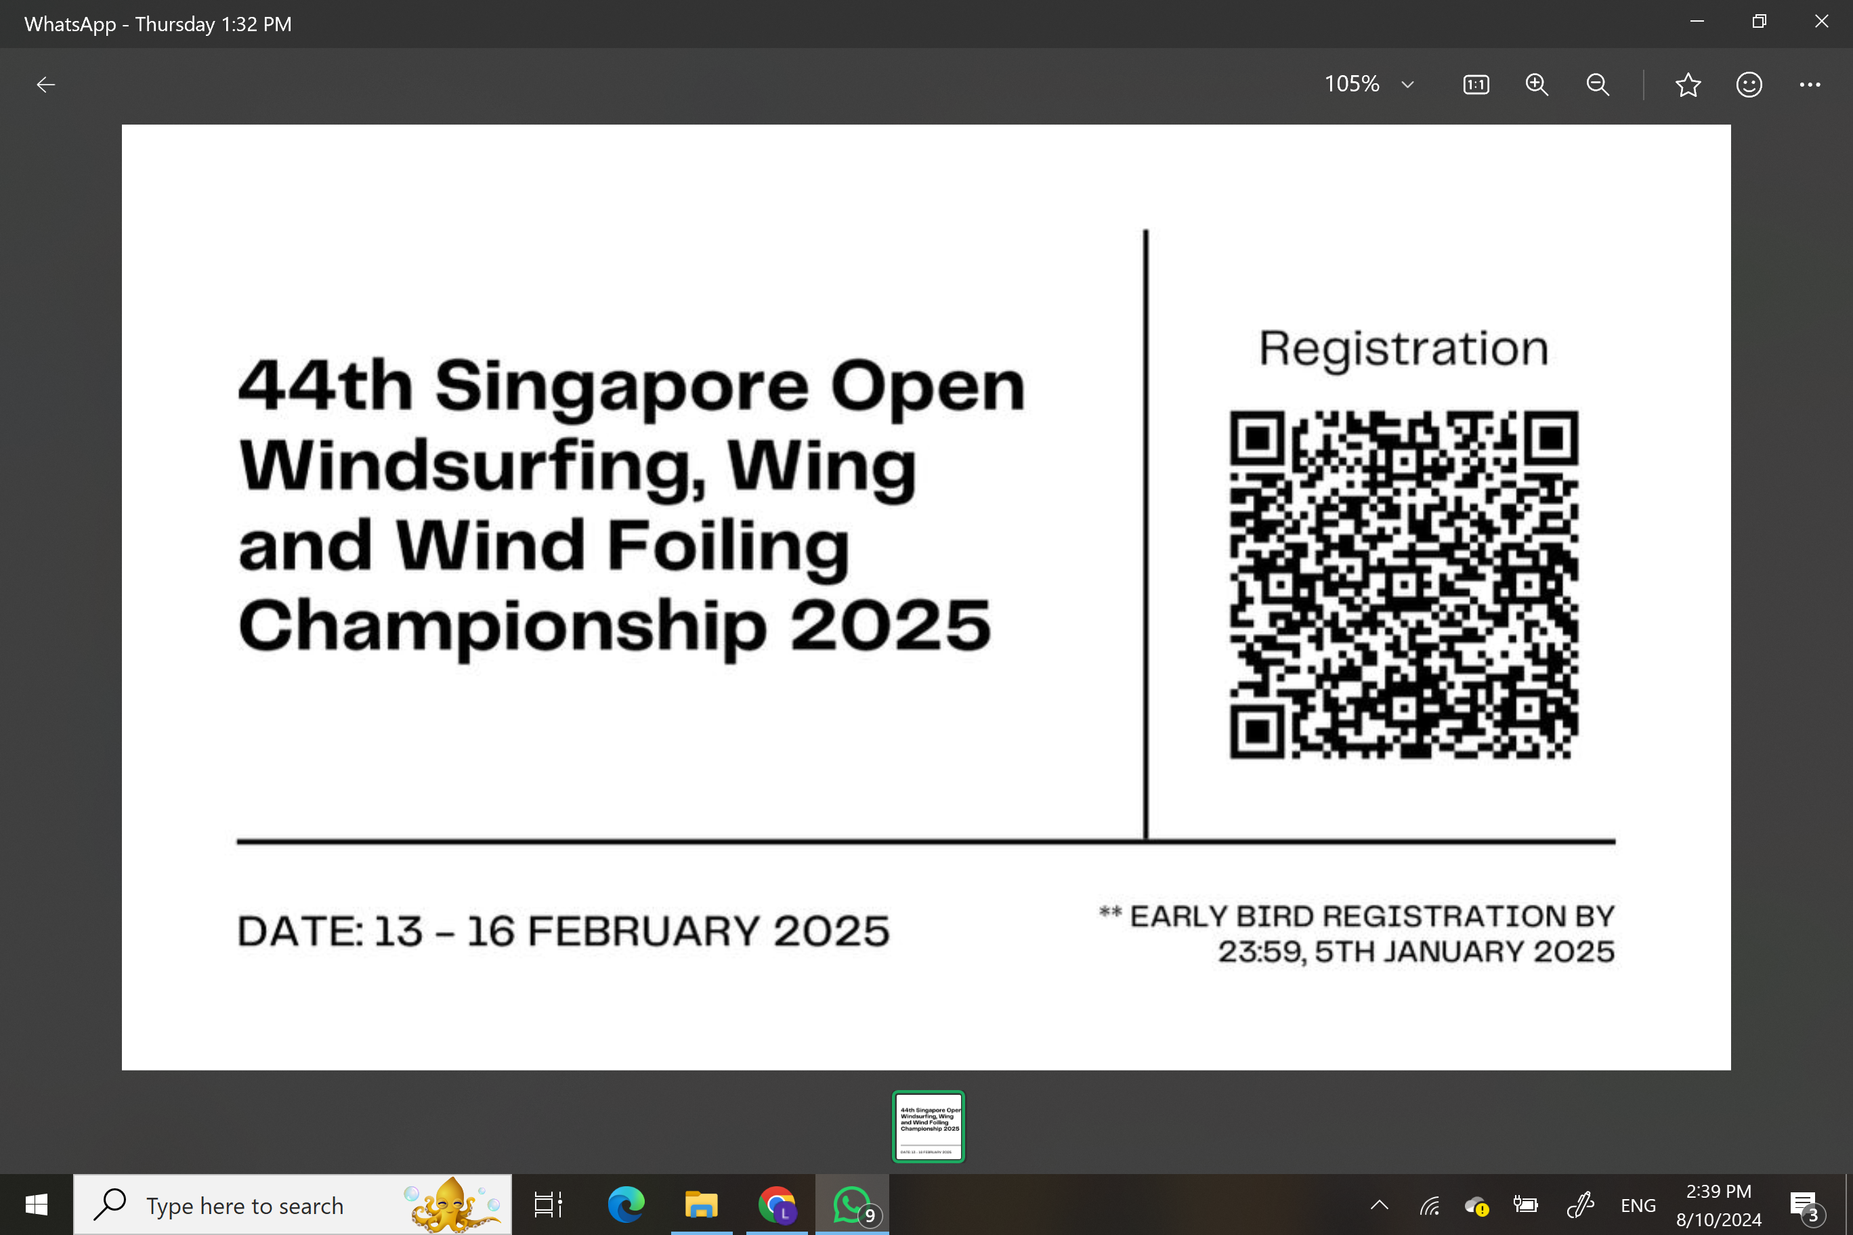

19.2 For enquiries on registration and payment matters, contact : Max Ong
Email:max@alohaseasports.com.sg Mobile: +65 83681289
19.3 For rental of boards and sail, please approach:
a) Constant Wind Sea Sports Centre for RS:One, Bic Techno, LT Windsurfer. Contact Kah Soon
Email: kahsoon@constantwind.com Mobile: +65 96796867
b) Aloha SeaSports Centre for IQ Foil. Contact Max Ong
Email: max@alohaseasports.com.sg Mobile: +65 83681289
19.4 For accommodation matters, contact Lemmy Teo
Email: lemmyteo@yahoo.com Mobile: +65 91880917
19.5 For general enquiries, contact WAS secretary:
Email: singaporewindsurfing@yahoo.com

44th Singapore Open Windsurfing, Wind and Wing Foiling Entry Form

Name: __________________________________________________ NRIC:_____________
Address:_____________________________________________________________________
Date of birth:______________________________________Gender:_____________________
Contact number:____________________________ Email______________________________
Sail number:________________ Club:_____________________________________________
National Class Association:_______________________________________________________

Entry Fees* (Fees are non- refundable)
The required entry fee for the following classes (4 days racing) are:
- S$180 for T293 Junior, IQ Foil U 17 and U19
- S$230 for T Plus & IQ Foil
For early bird** registration (see 2.2) , the entry fees are as follows:
- S$120 for T293 Junior, IQ Foil U 17 and U19
- S$180 for T Plus & IQ Foil

The required entry fee for following classes (2 days racing) are as follows:
- S$130 for Wind Foil, Wing Foil, RS:One, Windsurfer LT
For early bird** registration (see 2.2) the entry fees are as follows:
- S$80 for Wind Foil, Wing Foil, RS:One, Windsurfer LT
- S$50 for (Full time students) RS:One, Windsrufer LT

* Fees cover racing fees, lunch (during the respective racing days), t-shirt and 1 dinner. (Accommodation and rental of board & sail are not included)
** Early bird registration ends after time 23:59, date 5th January 2025

Classes:(Circle the appropriate Class and Division)
From 13/2/2025 to 16/2/2025:
Techno 293 (T293) – Junior Boy, Junior Girl; Youth Boy, Youth Girl
Techno 293 Plus (TPlus) – Open
IQ Foil U 17 – U17 Boy, U17 Girl
IQ Foil U 19 - U19 Boy, U19 Girl
IQ Foil Open - Men & Women
From 15/2/2025 to 16/2/2025:
Wind Foil - Open
Wing Foil - Men, Women, Masters, Grand Masters
RS:One - Open
Windsurfer LT - Grand Master, Master, Man, Women

Declaration by competitor
I agree to be governed by the World Sailing Racing Rules, the relevant Class Rules, the Notice of race and the Sailing Instructions and I accept the penalties assessed under these rules and such other action as may be taken hereunder, subject to such appeal and review procedures as are provided herein, as the final determination of any matter arising under these rules and I agree not to report to any court or tribunal not provided herein with respect to such determination. I accept that under RRS Fundamental Rule 4, it is my sole responsibility to decide whether or not to start or to continue to race or compete, and I agree not to report to any court or tribunal with respect to such a decision and its consequences.

----------------------------------------- -------------------------------------------------------------------------------
Competitor’s Signature & date Parent’s Name, signature & date (for sailors under 18 years)

